SUBASHREE.N-192521377
LAB EXPERIMENTS
EXP 12: Simple Programming using REPEAT, WHILE

OUTPUT:
1:
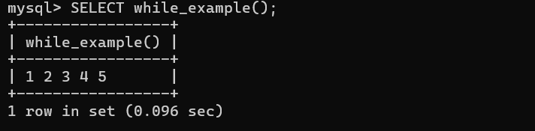
2:
